

**Task 9: Aqueous Solutions Topic Test**

**Question/Answer Booklet**

**CHEMISTRY UNIT 2**

Student Name: _____________________________________

Teacher’s Name: _____________________________________

# TIME ALLOWED FOR THIS PAPER

Working time for the paper: 45 minutes

# MATERIALS REQUIRED/RECOMMENDED FOR THIS PAPER

**To be provided by the supervisor:**

This Question/Answer Booklet

Chemistry Data Book

**To be provided by the candidate:**

Standard items: pens (blue/black preferred), pencils (including coloured), sharpener, eraser, correction tape/fluid, ruler, highlighters

Special items: up to three non-programmable calculators approved for use in the WACE examinations

# IMPORTANT NOTE TO CANDIDATES

No other items may be taken into the examination room. It is **your** responsibility to ensure that you do not have any unauthorised notes or other items of a non-personal nature in the examination room. If you have any unauthorised material with you, hand it to the supervisor **before** reading any further

**Multiple Choice Section(12 marks)**

1. When hot brine is cooled down until crystals of salt appear, a liquid remains. Which term best describes the remaining liquid?
2. Solute
3. Solvent
4. Saturated solution
5. Unsaturated solution
6. Which of the following contains only strong electrolytes (note: a strong electrolyte is any material that completely ionizes in solution)?
7. Sodium chloride, water, and sulfuric acid
8. Magnesium hydroxide, ammonia, and potassium chloride
9. Ethanoic acid, ammonia, and water
10. Magnesium hydroxide, sodium chloride, and potassium nitrate
11. Which of the following is the correct order of solutions in order of increasing electrical conductivity?
12. Methane < magnesium chloride < ethanoic acid < sulfuric acid
13. Sulfuric acid < methane < magnesium chloride < ethanoic acid
14. Methane < ethanoic acid < magnesium chloride < sulfuric acid
15. Ethanoic acid < methane < magnesium chloride < sulfuric acid
16. If you have 500 mL of 2M strong acid there will be:
    1. 2 molL-1 of H+
    2. 1 molL-1 of H+
    3. 0.5 molL-1 of H+
    4. 4 molL-1 of H+

**Questions 5 and 6 relate to the graph shown below.**

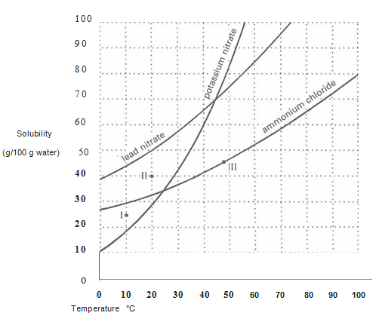

1. To completely dissolve 15g of lead nitrate in 20g of water, the temperature would have to be at least:
2. 20°C
3. 30°C
4. 40°C
5. 50°C
6. Points I, II, and III on the graph represent three solutions of ammonium chloride. Which point represents a super-saturated solution?
7. I
8. II
9. III
10. None

**Short Answer Section(18 marks)**

**Question 1(4 marks)**To aid in the precipitation of different halides, a solution of silver sulphate is prepared using 0.5142g of solid and 500.0mL of water.

1. Calculate the amount of silver sulphate (in mol)(1 mark)
2. Using this information, calculate the concentration of silver sulphate (in mol/L) in the solution(1 mark)
3. Using your answer from part b, would you expect all the silver sulphate to dissolve? Why/why not?(2 marks)

___________________________________________________________________

___________________________________________________________________

**Question 2(4 marks)**Write balanced chemical equations for each of the following reactions:

1. sodium hydroxide solution and ethanoic acid(2 marks)
2. calcium carbonate in a flask of hydrochloric acid(2 marks)

**Question 3(6 marks)**A 125 mL, 0.4 M solution of barium nitrate is mixed with potassium sulphate solution to form a precipitate

1. Write a balanced net-ionic equation and clearly identify the precipitate formed.(3 marks)
2. Calculate the mass of the resulting precipitate.(3 marks)

**Question 3(4 marks)**A brand of household mould cleaner contains 2.4g/L of sodium hydroxide (NaOH).

1. Determine the concentration in moles per litre.(2 marks)
2. Determine how many moles of sodium hydroxide are present in a 250mL bottle.(1 mark)
3. What is the concentration of this solution in ppm?(1 mark)

**Extended Response Section(15 marks)**

Universal indicator is a type of indicator used to measure the pH of different acids and bases. Unlike most indicators, which are a single chemical compound, universal indicator is instead a mixture made up of four different indicators – thymol blue, methyl red, bromothymol blue, and phenolphthalein.

Some information about these indicators is provided below.

-1 0 1 2 3 4 5 6 7 8 9 10 11 12 13 14

pH

|  |  |  |  |  |  |  |
| --- | --- | --- | --- | --- | --- | --- |
| thymol blue | red | yellow | | | blue | |
| methyl orange | red | | yellow | | | |
| bromothymol blue | yellow | | | blue | | |
| phenolphthalein | colourless | | | | | pink |

1. In the space below, indicate the colour you would expect each solution to be for the provided indicator.(3 marks)

|  |  |  |  |
| --- | --- | --- | --- |
|  | Strong Acid | Neutral | Strong Base |
| thymol blue |  |  |  |
| methyl orange |  |  |  |
| phenolphthalein |  |  |  |

1. Name one limitation associated with the use of phenolphthalein, and describe why universal indicator can overcome that limitation.(2 marks)

__________________________________________________________________________________________________________________________________________________

1. Two samples of hydrochloric acid were tested with universal indicator – one turned red, while the other turned yellow. Give a reason why these two samples could produce two different colours despite being the same strength.(2 marks)

____________________________________________________________________________________________________________________________________________________________________________________________________________________________________________________________________________________________________

The following solutions were tested with different indicators, and produced the following colours:

|  |  |  |  |
| --- | --- | --- | --- |
|  | thymol blue | methyl orange | phenolphthalein |
| Solution X | yellow | red | colourless |
| Solution Y | yellow | yellow | colourless |
| Solution Z | yellow | yellow | pink |

1. What pH range would you classify each solution as?(3 marks)

Solution X:

Solution Y:

Solution Z:

Solution Y was later tested with bromothymol blue, which caused it to turn blue. It was later identified that one of the solutions contained ammonia, and the other contained sodium hydroxide.

1. Determine which solution was ammonia, and which solution was sodium hydroxide. Explain your reasoning, using chemical equations where relevant to support your answer.(5 marks)

____________________________________________________________________________________________________________________________________________________________________________________________________________________________________________________________________________________________________

____________________________________________________________________________________________________________________________________________________________________________________________________________________________________________________________________________________________________

**End of Test**